WIFI+4G dongle cannot connect to the network using 4G
Author：胡维
Reviewer：Eason
FAQ\Network Communication
Issue introduction
When using a Wi-Fi + 4G module and you need to use 4G for network configuration and remote monitoring, an issue occurs.
Confirmation of basic information
[Photo]SN number of the inverter and pocket.
Ensure that the IoT SIM card being used supports CAT-M and NB-IoT standards.
Guidance for installer
Step1: Go to the local menu <About> via the inverter screen to see if the inverter has successfully recognised the inserted pocket Resister SN number.
Settings path: About → Inverter → Resister SN
If the "Register SN" on the inverter is same with the dongle, the connection between dongle and inverter is normal.
INV side | Dongle side
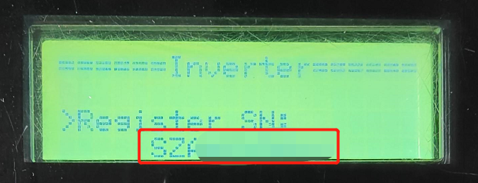  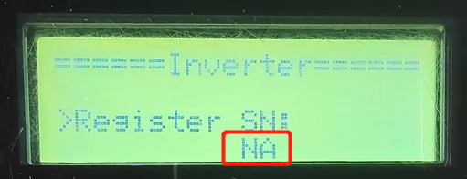 | 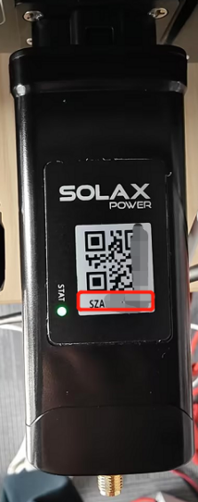
If “NA” is displayed, Check the silkscreen on the dongle's USB port to make sure it is not damaged. re-plug the dongle to make a good connection between the inverter and the dongle.
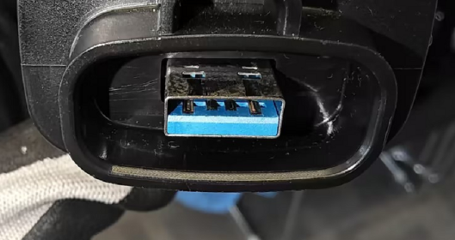
If “NA” is still displayed,Remove the internal components of the pocket and verify whether the pocket is damaged.First, locate the recessed clips on both sides of the pocket.
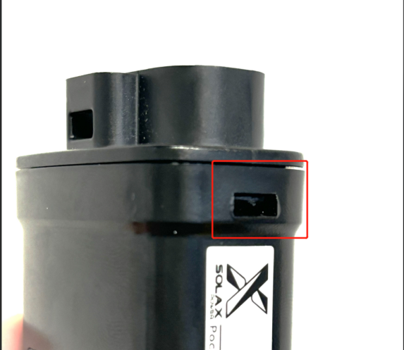
Use a flat-head screwdriver to find a downward-slanting angle, insert it into the slot, and gently pry downward. | Continue until the screwdriver is positioned as shown in the image, perpendicular to the side of the pocket.
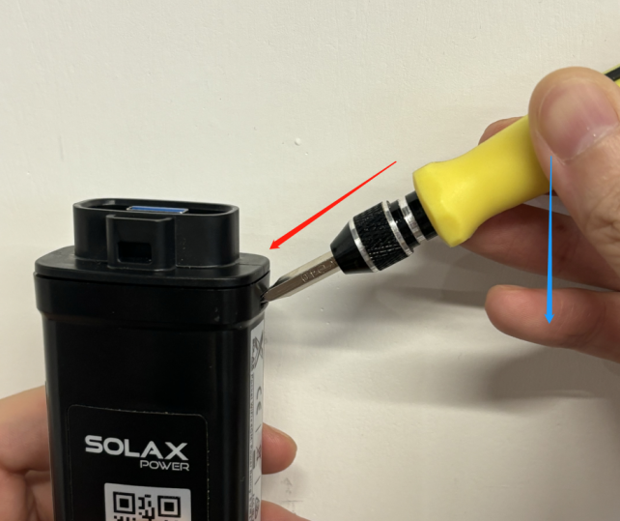 | 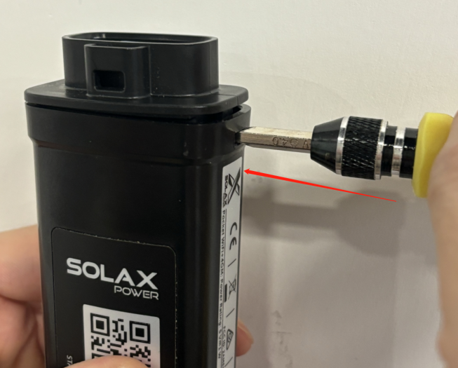
Do the same on the other side, then remove the front cover and take out the internal components.（There may be communication cables adhered inside; as shown in the image, removing half of them is sufficient.）
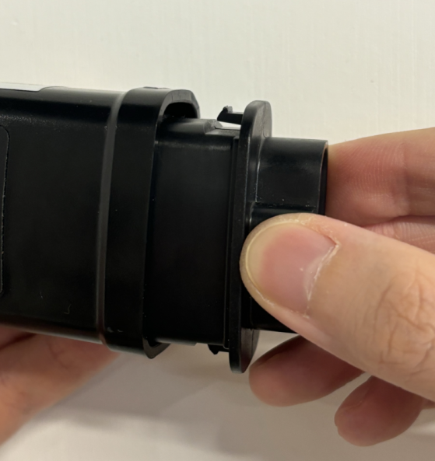 |  | 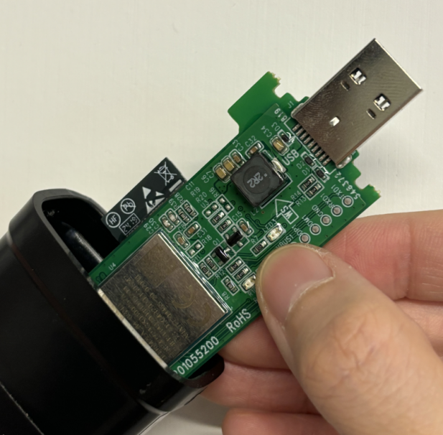
Reinsert the inverter and check if it successfully connects to the network.If not, replace the pocket.
If the connection is successful, return to Step 1 and reinsert the pocket to ensure it is securely connected.When restoring the pocket, make sure the USB is inserted into the position shown in the image, and the side of the top cover with the hole should face the same direction as the side with the QR code.
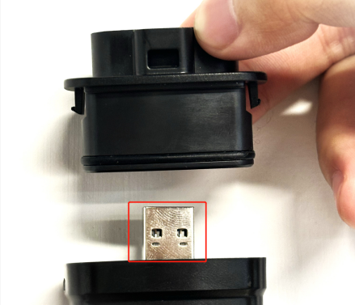
Step2：Use a Phillips screwdriver to unscrew the screws at the bottom and open the back cover.
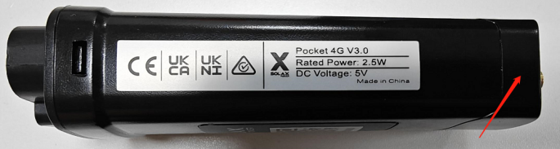
Reinsert the IoT SIM card. When the dongle's QR code is facing up, the notch on the card should be at the top right of the card slot.
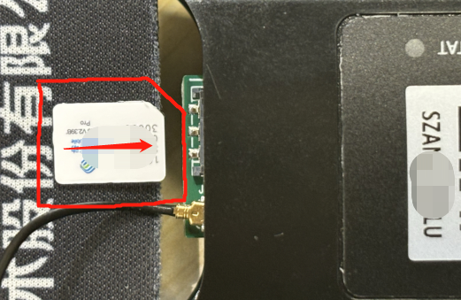
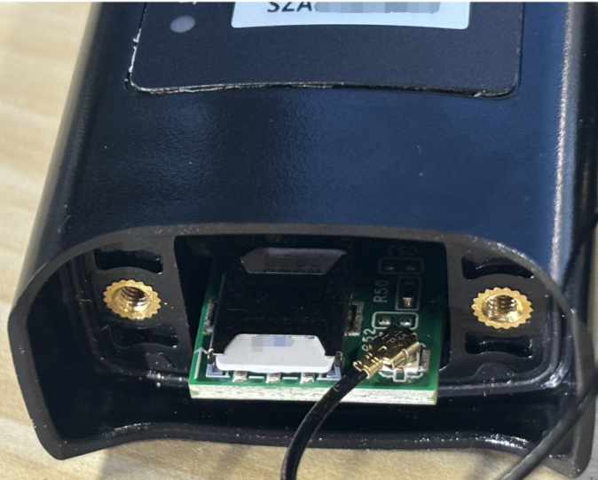
Step3: Reinsert the inverter, Open the solaxcloud APP, then click “More” → “Local” → “Scan” in turn.
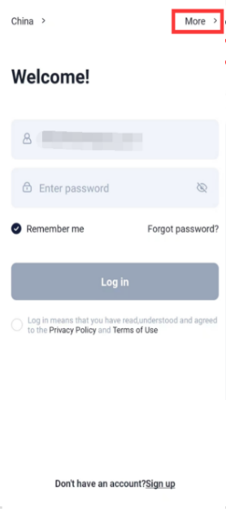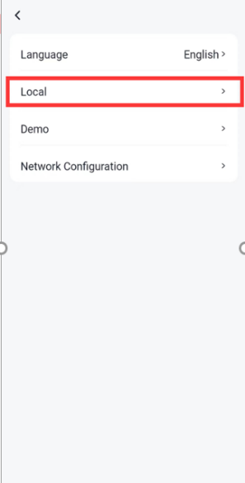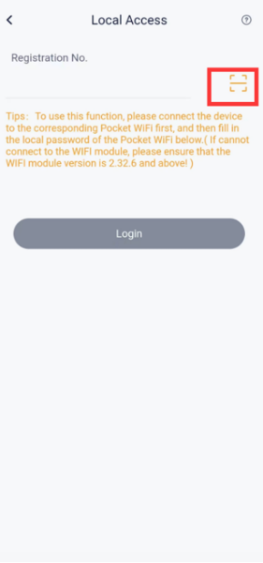
Scan the QR code on dongle then click ‘Login’ to local enter.
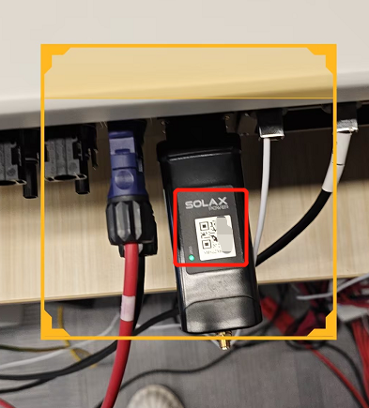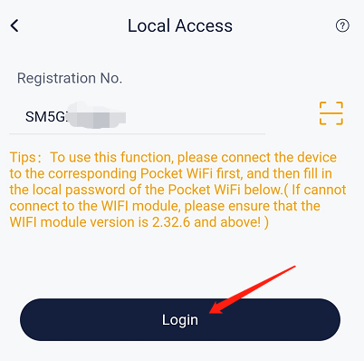
Follow the steps below (from left to right) to find the screen to fill in the APN information.Consult your IoT SIM card operator for the relevant APN information, and save it after filling it in.
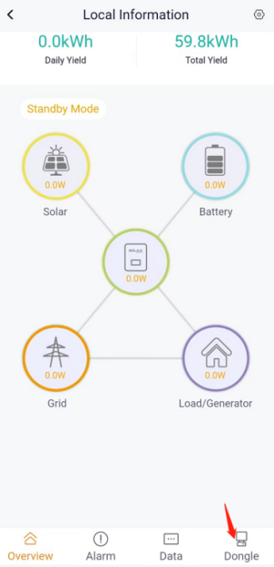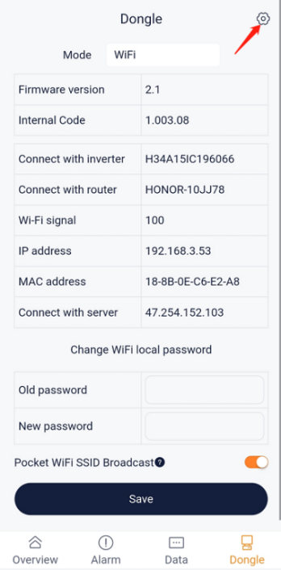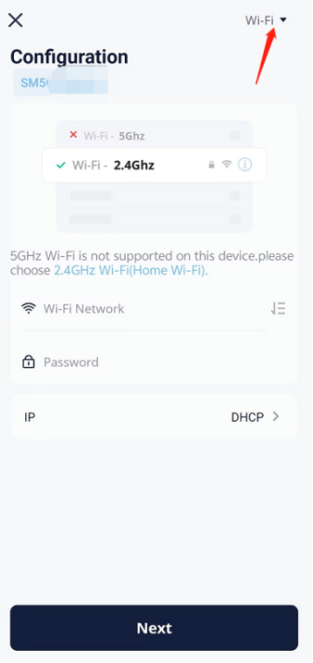
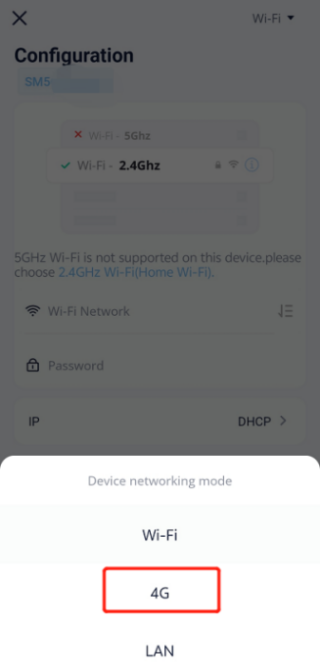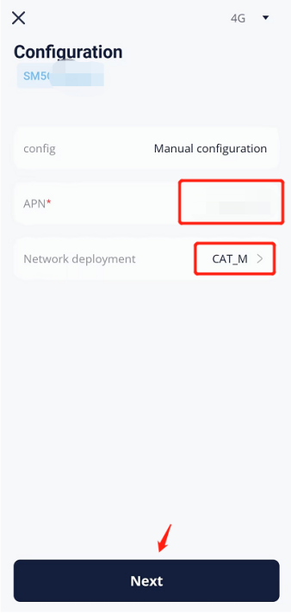
Step5:Check the dongle status indicator,the status light should remain solid red when the network is successfully configured and the system is operating normally.
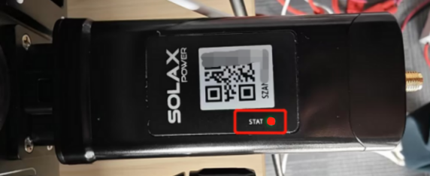
If it still fails to connect to the network, contact the Solax team and send your IoT SIM card's APN information. We need to verify whether your carrier and APN are on our whitelist.
Information check list
If you have completed the above <Guidance for installer>, and the problem is still not solved, please collect the following troubleshooting information and send them to the R&D.
1.[Photo] SN number of the inverter and pocket, which should clearly display the registration number.
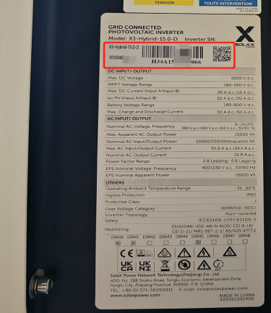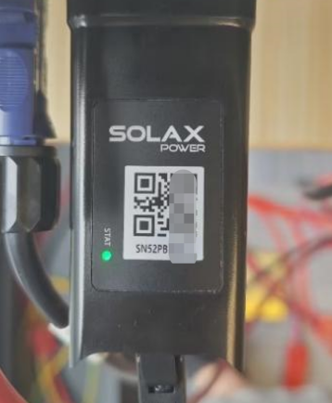
2.[Video] Dongle status indicator.
3.[Photo] The Register SN on the inverter LCD display.
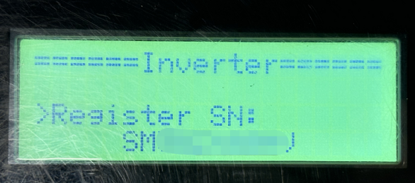
4.[Photo] The USB port of the dongle.

5.[Photo] APN and Network deployment information.
